CARR Home Page Links

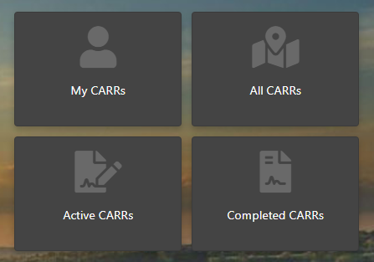

### My CARRs:

All Roles:

RoutedTo = login id

### All CARRs:

Role:

Sales – CARRs where SalesProfessional = Login and ActiveFlag=true

SalesRM – Where Decision Maker Branch = SalesRM Region and ActiveFlag=true

SalesDM – Where Decision Maker Branch in SalesDM District and ActiveFlag=true

DFL, Operations, Corporate – All CARRS where ActiveFlag = true

### Active CARRs:

All CARRs as specified above, where CurrentFlag=true and CompletedFlag=false and ActiveFlag=true

### Completed CARRs:

All CARRs as specified above, where CurrentFlag=true and CompletedFlag=true and ActiveFlag=true